Exercise 17:
- SELECT e_id, s_name FROM employee_personalinfo WHERE m_status='Yes';
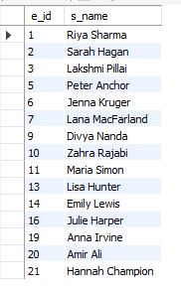
- SELECT e_id, s_name FROM employee_personalinfo WHERE m_status='Yes' ORDER BY s_name ASC;
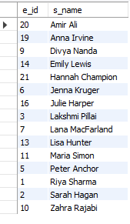
- SELECT sex, COUNT(*) AS count FROM employee_personalinfo GROUP BY sex;
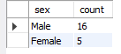

- SELECT m_status AS marital_status, COUNT(*) AS count FROM employee_personalinfo GROUP BY m_status;
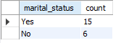
- SELECT SUM(children) AS total_children FROM employee_personalinfo;

- SELECT children, COUNT(*) AS number_of_employees FROM employee_personalinfo GROUP BY children ORDER BY number_of_employees DESC;
